Musselshell Watershed Coalition
Salinity Meter End of Season Assessment: November 2017
Summary prepared by John Lange and Adam Sigler 11/8/2017
On November, 8th 2017, all 5 meters were assessed at the same time for reading agreement. This was conducted at the USDA NRCS Field Office in Winnett, MT by John Lange. All five meters were placed in the same tub of water and readings were recorded simultaneously while slugs of salt water were added to assess agreement among the meters over the range of salinities observed during the monitoring season. The full results are in the table below. Four of the meters had maximum relative percent difference (RPD) from the mean of less than 4%. The ProPlus meter had RPD from the mean ranging up to over 8%. The maximum difference was approximately a percent lower if meters were allowed to equilibrate for 2 minutes in the salt water solution.
RPD was calculated as the percent difference of each meter from the mean of all the meters.

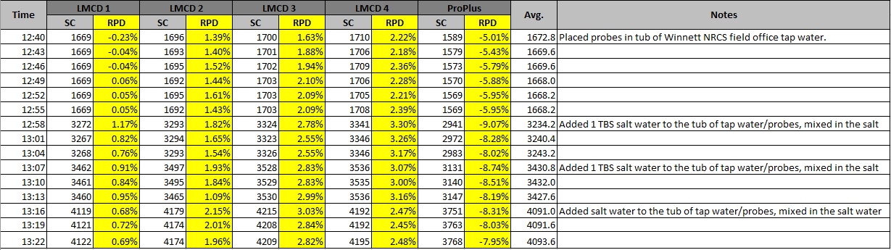
John Lange subsequently recorded meter readings in 1413 solution before and after cleaning the meter electrodes. The RPD between pre and post cleaning was greater than 3% for meters LMCD 2 and LMCD 4, suggesting these meters need to be cleaned more regularly during the season.
After cleaning, all meters read within 3% of the 1413 uS solution.
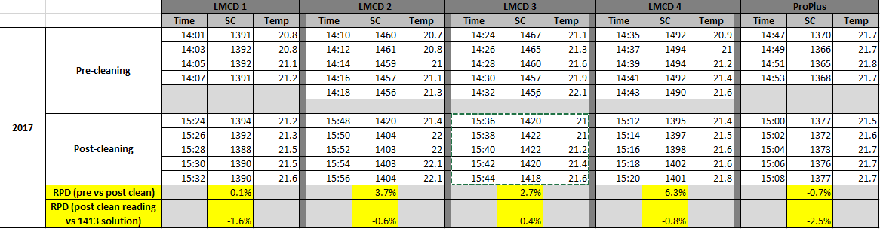
In summary, at the end of the season, post cleaning, all meters read within 3% of the 1413 uS solution. This verified high level of accuracy without calibration during the season indicates that the current procedure of calibrating only once at the beginning of the season and checking again at the end produces accurate results while dramatically reducing strain on volunteers. Differences among meters was consistently under 10%. Some of the difference among meters may be explained by different levels of fouling on the meters during the season. This suggests that the SC probes on the meters should be cleaned with pipe cleaners more regularly during the season (perhaps monthly).

