Ruby Stream Team
Standard Operating Procedures (SOPs)

Table of Contents
Gear Checklist 2
Field Activity Checklist 3
Site Locations 3
Site Photos 4
Establishing New Sites 6
Turbidity Measurement with Secchi Tube 7
Turbidity Measurement with HACH 2100Q Turbidimeter 8
Example Turbidity Sheet 10
Calibrating the HACH 2100Q Turbidimeter 11
Discharge Using the Marsh-McBirney FLO-Mate Meter 12
Discharge Using the Float Method 15

Gear Checklist

Turbidity
- SAP/SOP
- Landowner Consent Form
- Clipboard
- Turbidimeter with sample vials
- Kim Wipes (lint free clothes)
- Turbidity datasheets
- Pencils and Extra lead
- Camera
- First aid kit

Discharge with meter
- Marsh McBirney flow meter
- Marsh McBirney top setting rod
- Extra batteries for flow meter (2 C)
- Nylon tape with tenths of feet
- 2 bank pins
- Discharge datasheet
- Clipboard
- Pencil
- Multi-tool or screwdriver

Discharge with float method
- 100 foot tape measure
- Bank pins (5)
- Stop watch
- Discharge datasheets
- Stick for measuring water depth (PVC pipe with marks on it)
- Calculator
- 3 to 5 wood blocks or oranges
- Twine or rope
- Fishing net with long handle to catch blocks (for teams with only 2 people)

Personal Items
1. Cell Phone
2. Sun screen
3. Waders
4. Bug spray

Other
- Turbidity Tube
- Bucket to fill tube
- Life Jacket (pfd)
- Backpack to carry gear

Field Activity Checklist
- Measure Turbidity with the turbidity meter
- Fill out Turbidity on datasheet
- Take photo points
- Check that all forms are complete
- Check that all gear is accounted for

Site Locations
*Underlined parameters will be processed by the lab
Site | Site Description | Latitude | Longitude | Parameters | Justification of Site Selection
R_RHF_B3B | Ruby River at Ruby Habitation Foundation Beat 3 Bridge | 45.373465° | -112.142101° | Turbidity | On public land, easy access. Collect sample upstream of bridge and upstream of the first rocky riffle line
C_RHF_CNF | California Creek at Ruby Habitat Foundation upstream of confluence with Ruby River | 45.373158° | -112.134245° | Turbidity | On public land, easy access. Collect sample ~ 50 ft upstream of wood planks near the confluence
I_MLC_URP | Indian Creek at Morse Land Co. Upper Revegetation Plot | 45.461242, | -112.269991 | Turbidity, Discharge | Site that Dave McAdoo will be near daily for work. Landowner possibility interested as well.

Table 1: Site locations

Site Photos
Ruby River at Ruby Habitation Foundation Beat 3 Bridge
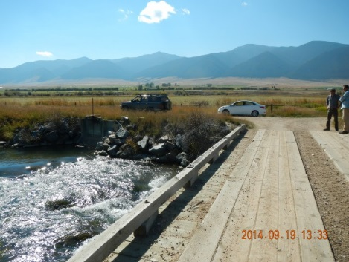  Beat 3 Bridge looking towards the Gravelly’s  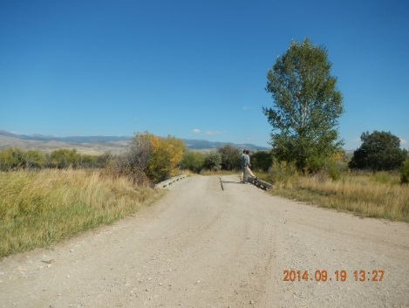  Beat 3 Bridge looking toward the Tobacco Root foothills | 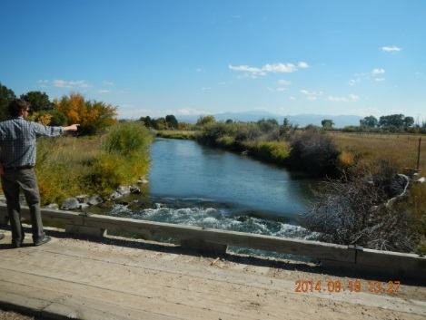  Beat 3 Bridge looking upstream  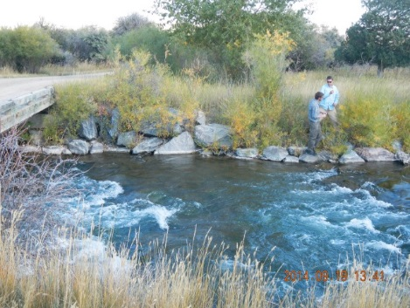  Beat 3 Bridge sampling site (upstream of bridge) | 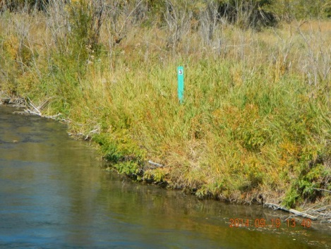  Beat 3 sign  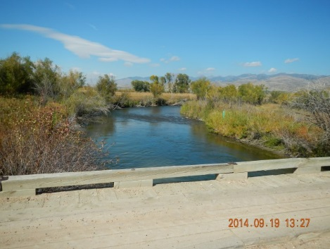  Beat 3 Bridge looking downstream
California Creek at Ruby Habitat Foundation upstream of confluence with Ruby River
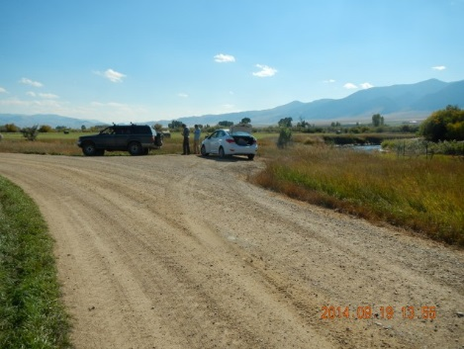  Parking pullout near California Creek and Ruby River confluence  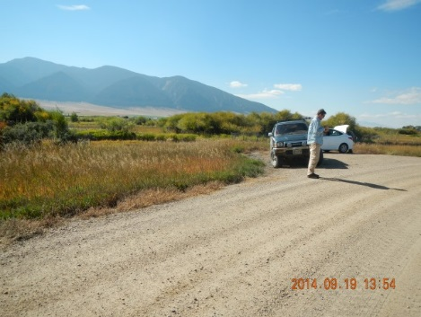  Parking pullout near California Creek and Ruby River confluence | 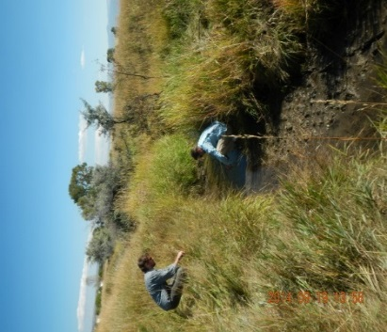  California Creek looking upstream  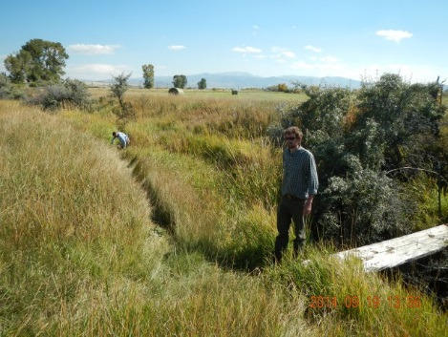California Creek looking upstream | 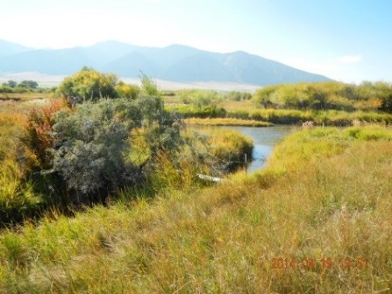  California Creek looking downstream at confluence with the Ruby River.  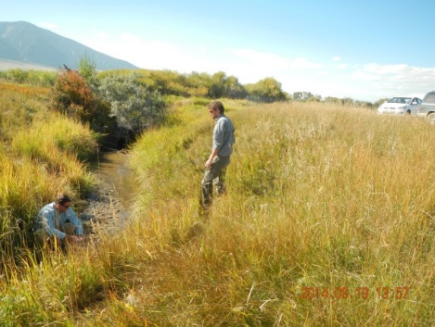  California Creek looking downstream
Indian Creek at Morse Land Co. Upper Re-vegetation Plot
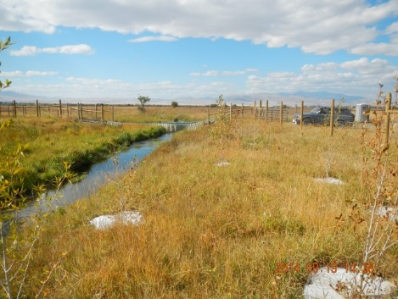  Indian Creek looking downstream  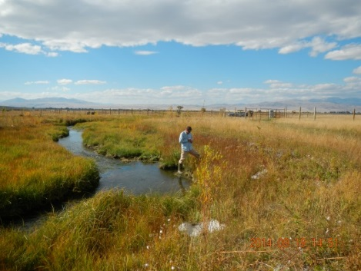  Indian Creek looking downstream | 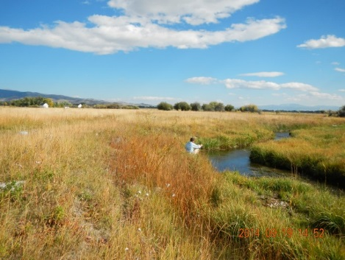  Indian Creek looking upstream  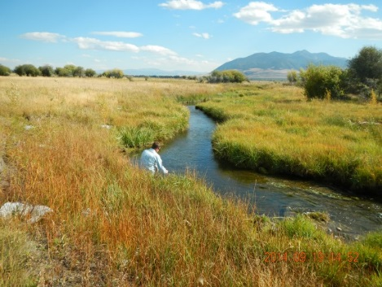  Indian Creek looking upstream | 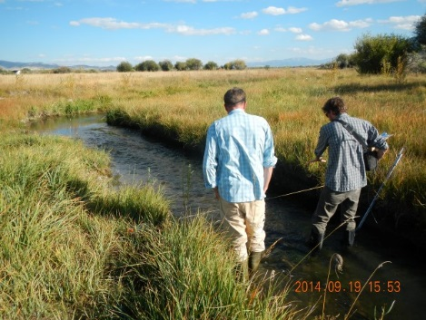  Indian Creek – discharge location  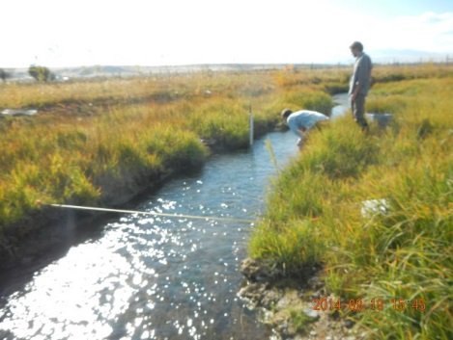  Indian Creek – discharge location

Establishing New Sites
Please follow the below steps to establish new sampling sites (site establishment can be done by volunteers or RVWC members):
- GPS coordinates must be collected and recorded at the site (preferably in decimal degrees)
- Take photos at the site: cross section, downstream photo, upstream photo, where to park, etc. If possible, take a picture of a person collecting the sample
- Create a sample name for the location. Sites already established, have followed the format below:
  - First letter of water body _ general location abbreviation _ further description of sample location
    - For example: C_RHF_CNF stands for California Creek_at the Ruby Habitat Foundation_near the confluence.
  - Along with creating a name, write a brief description of the site and reasoning behind establishing it.
- Record the GPS coordinates, site name, site description, on a piece of paper and send the information (or drop off the paper) to Rebecca Ramsey. Make sure to also deliver or email the photos. The new site information will then get incorporated in the site location table in the SAP and SOP.

Turbidity Measurement with Secchi Tube

- Turbidity measurements should be taken as quickly as possible to get the measurement before particles settle out and make the sample less turbid.

- The secchi tube should be filled with water from the active portion of flow, making sure there is no upstream disturbance taking place.

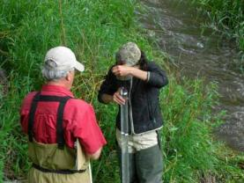
- The tube should be filled all the way to the zero line near the top which may require adding additional water from the stream with a bucket.

- Measurements are taken by standing over the secchi tube and looking straight down the tube.

- Stand with your back to the sun so the tube is in your shadow and remove sunglasses before taking a reading.

- Lower the secchi disk in the tube until it disappears. Pinch the cord against the tube to hold it in place and look through the side of the tube to determine the depth of the disk in the tube.

- If the disk is visible at the bottom of the tube, the reading is recorded as greater than the depth of the tube. This means the water is too clear to measure with this tube.

- Record the measurements (in centimeters) on the datasheet.

- Repeats steps 2 through 7 twice more, record each reading on the datasheet, and calculate the average of the 3 readings.
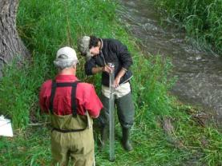

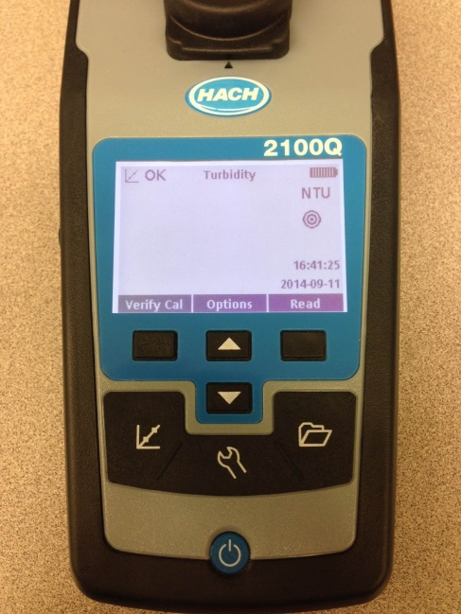
Turbidity Measurement with HACH 2100Q Turbidimeter
- Before using the turbidimeter, perform a Calibration Verification check.
  - Turn the meter on (blue circle button near bottom of meter)
  - Pick out the 10 NTU Verification Standard from the turbidimeter case.
  - Shake it vigorously for a 10 seconds
  - Let it sit undisturbed for 3-5 minutes (to allow air bubbles to dissipate)
  - Hold the vial by the cap and wipe the glass with a lint free cloth or Kim wipe and be careful not to touch the glass.
  - Insert the standard into the sample cell well, line up the orientation arrow on the bottle and the meter and press “Verify cal’ button (square highlighted button in Image 1).
Image 1: ‘Verify cal’ button

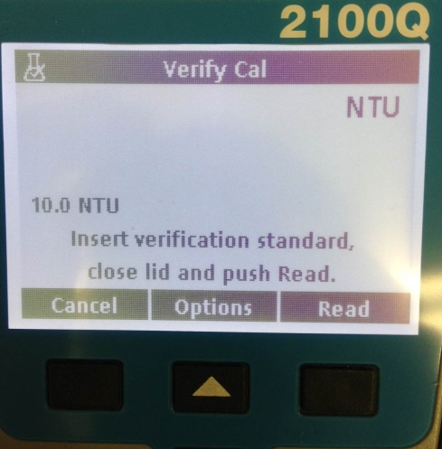

Image 2: Succession of screen views once verify calibration process is started

  - The first screen in image 2 will appear. Press the read button, the meter will stabilize for a few seconds (second scree in image 2) and then you will be notified if the calibration verification passed.
    - If the verification calibration is not successful, perform a 3 point calibrate with the meter.

Analyzing a Water Sample with the Turbidimeter
- If you are collecting samples with plastic vials to return to another location to measure them; label the plastic bottle with a permanent marker before collecting the sample. Label the bottle with site ID from the SOP, date and time.
- Make sure you are at the correct sample site location and collect water from a well-mixed portion of the stream
- Bottle and lid should be triple rinsed prior to collecting the sample.
  - When collecting the sample, face upstream and draw the bottle through the water column once and carefully avoid disturbing the bottom sediments.
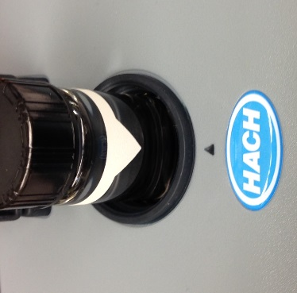
- Replace the lid on the sample bottle and bring the water sample back to the shore.
- The HACH 2100Q comes with empty glass vials. There should be a vial under the black cap that is filled with DI or tap water. Empty this vial.
- Fill the glass vial with sample water to the white line.
- By holding the vial by the plastic cap, carefully wipe the glass with a lint free cloth or Kim wipe and be careful not to touch the glass. You want to make sure the glass if free of all water, fingerprints, oil and dirt.
Image 1: Align the white orientation arrow with back orientation mark on the meter.
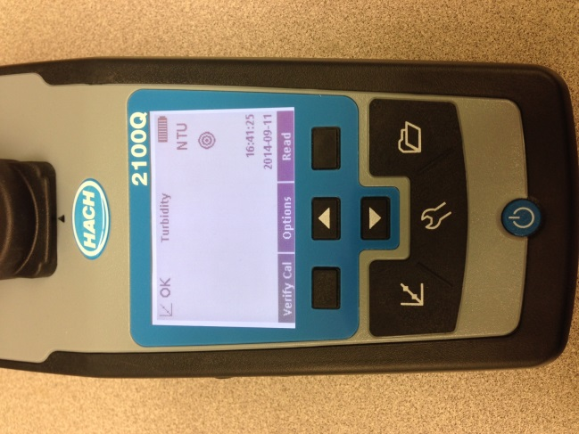
- Gently invert the sample a few times and insert the sample vial with the white orientation bar and arrow in line with orientation mark in front of the cell compartment (image 1)
- Close the compartment and immediately press ‘Read’ (image 2)
- The turbidimeter will beep when it is finished reading the sample
- Record this number on your field sheet.
- Remove the vial from the sample well and gently invert a few times, put the vial back in the sample and take another reading.
- Record on the reading on your data sheet
- Repeat this process one more time and record the reading on the datasheet
- You should now have 3 readings recorded on the datasheet.
- Empty the sample vial and rinse three times with tap water. To store the sample vial, fill with clean tap water to the shoulder of the vial.
Image 2: The read button is highlighted by the yellow circle above.

Example Turbidity Sheet

Calibrating the HACH 2100Q Turbidimeter

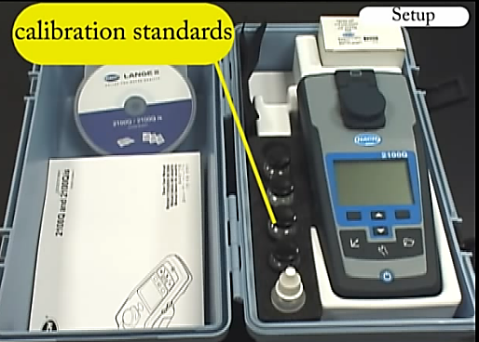
Calibration is required quarterly and calibration verification is recommended before each use.
- You will need calibration standards 20, 100, and 800. These should be in the case in the black foam holder (Image 1)
- Turn on the meter
- Press the calibration key that looks like a graph (Image 2)
- Follow the prompts on-screen
- Once calibration is complete, a Calibration Details screen will appear. Hit the store button and record the calibration details in a written log
Image 1: Turbidimeter contents
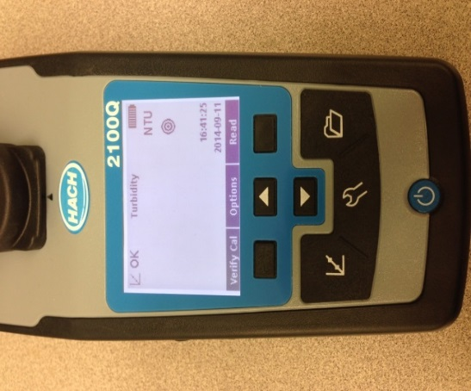
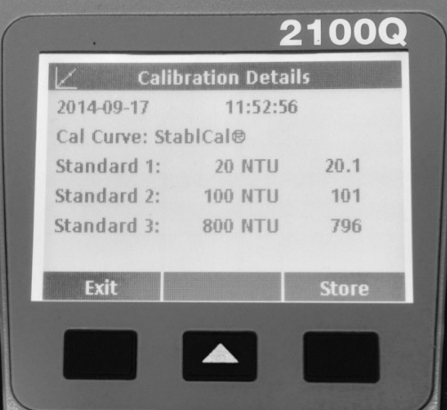

Image 3: Calibration details screen
Image 2: Calibration button

You can watch a video of the calibration process at:
https://www.youtube.com/watch?v=zb_Ogaa8xDc#t=361

Discharge Using the Marsh-McBirney FLO-Mate Meter
Equipment and Supplies
- 100’ reel-type tape measure
- 2 tent stakes (hammer optional if needed)
- FLO-Mate unit
- Measuring rod

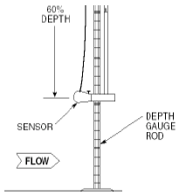
FLO-Mate Sensor Mounting
Mounting instructions are as follows:
- Insert the mounting shaft into the hole at the back of the sensor.
- The thumbscrew needs to be seated in the groove, so make sure the shaft is completely inserted into the hole.
- Hand tighten the thumbscrew.

[CAUTION]
Do not over tighten the thumbscrew on the sensor. Excessive force on the thumbscrew could damage the sensor.

Overview of Steps:
- Locate a reach of stream that is not being immediately disrupted by obstacles upstream (boulders, logs, etc.) and is relatively straight and without backwaters or side channels.
- Stretch a tape measure across the channel perpendicular to the channel and pin it in place to establish the cross-section.
- Measure the wetted width of the channel by looking at where the tape intersects the left and right edges of the wet portion of the channel and subtracting the smaller number from the larger. Measurements should be made in tenths of a foot for ease of math. Record this wetted width on the data sheet.
- Divide the wetted width into 20 even intervals for depth measurement. You can round to the nearest number that will make the math easier (maybe to the nearest quarter foot).
- Start on the left wetted edge of the channel (left and right edge is determined when looking downstream), and record the tape measurement at that location with a zero water depth (the wetted edge). Continue measuring depths across the channel at your determined interval. You should finish on the opposite wetted edge with a zero measurement and should have at least 20 measurements.
At each location three numbers will be recorded: the location on the tape, the water depth and the velocity. Instructions for its operation are below:

Using the Top Setting Rod
Because stream velocities differ at various depths within the channel, an accepted method for determining mean velocities of flows is to measure the velocity at 60% of the depth (from the top) and use this as the mean.
- Set the rod at the first tape interval determined by the stream width measurement. Note the height of the water on the top setting rod and move the small rod to the appropriate position. Each single mark represents 0.10 foot, each double mark represents 0.50 foot, and each triple mark represents 1.00 foot.
  - For example, if the water depth reads 0.8 feet on the rod, you move the small, sliding rod so the 0 aligns with the 8 at the top.
  - If the water level was 2.3 feet, you move the sliding rod so the 2 on the sliding rod is in line with the 3 on the top of the rod.

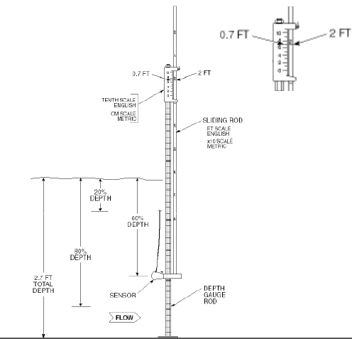

- Turn the meter on.
- The first set of screens you see appear below. The velocity output display will resume measuring average velocity for a 30 second period.
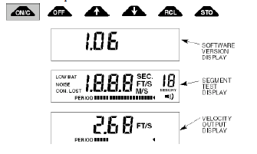

- Clear the display by hitting the ON/C button once.
- The unit display will begin averaging by showing the horizontal time bar under the velocity output. The period (time) bar provides an indication as to the amount of time left until the display is updated.
- At the end of the averaging period, record the value indicated in the “velocity” column on the field form.
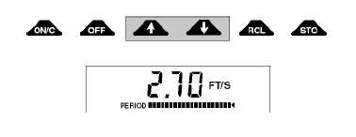

- Move the top setting rod to the next increment on the tape, note the depth and set the appropriate height on the small rod. Record the tape and depth measurements on the field sheet.
- Press ‘clear’ on the meter and meter will clear all previous values and will start a new average velocity. Once the period bar gets to the end, record the velocity value on the datasheet.
- Continue steps 7-8 until you reach the other side of the stream.

Discharge Using the Float Method
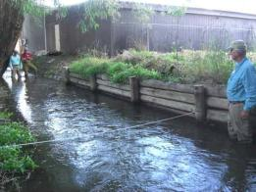
Equipment and Supplies
- 100’ reel-type tape measure
- 4 tent stakes (hammer optional if needed)
- twine
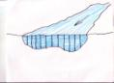
- 6 wood blocks (2” x 4” cut 6” in length) or oranges
- Stopwatch, timer, or watch with second hand

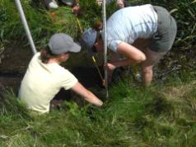
- Locate a relatively straight reach of stream to conduct the measurement. Ideally this will be 100 feet long, but as short as 15 feet is acceptable if it is the only option.
- Stretch a tape measure across the channel at the downstream end of the reach. This should be perpendicular to the channel.
- Measure the wetted width of the channel by looking at where the tape intersects the left and right edges and subtracting the smaller number from the larger. Measurements should be made in tenths of a foot for ease of math. Record this wetted width on the data sheet.
- Divide the wetted width into 20 even intervals for depth measurement. You can round to the nearest number that will make the math easier (maybe to the nearest quarter foot).
- Start at one wetted edge of the channel, and record the tape measurement at that location with a zero depth. Continue measuring depths across the channel at your determined interval.
- You should finish on the opposite wetted edge with a zero measurement and should have approximately 20 depth measurements.
- Total the depths and divide by the number of measurements (including the 2 zeros) to get the average depth.
- Replace the tape with twine to mark the bottom of the reach.
- Walk half way up your reach and take the second wetted width measurement. Record this on the sheet.
- Walk to the top of the reach and record the third wetted width.
- Leave the tape in place and use it to mark the top of the reach.
- Toss your floating object into the stream 5 to 10 feet up stream from the tape and start the timer when it crosses the line. Stop the timer when it reaches the bottom. Catch the object and repeat 10 times.
- Finish filling out the datasheet to calculate discharge using your average depth, average width and average speed of water with the correction factor.

Photo Points

Photos for the first season of data collection in the Ruby are simply to be done on volunteer phones, without extensive documentation. The following detailed procedures are included for insight about how more detailed photo monitoring might go for enhanced data collection in the future.

Considerations When Taking Photographs
It is critical that photo-point photographs are an exact replicate of previous photos. This will require the use of the Site Guide for each location that includes directions to the site and instructions for locating and repeating photos. The first thing you need to do is locate the position that the photograph is to be taken from. The second task is to identify the features in the photo that let you know you are repeating it exactly. In addition to photo-point photographs, supplementary photographs can be taken at the photographer’s discretion to document interesting conditions at the site. Artistic expression is encouraged as some photos may be used on websites and in slide shows. Season and weather conditions should be considered when scheduling monitoring events especially if there are implications for site accessibility. Scheduling events to capture different stream flow levels and seasonal changes in vegetation can be advantageous. The camera should not be zoomed in unless specifically directed in the Site Guide.

Equipment Needed
Required:
- Camera and backup camera
- Site Guide
- SOP
- White board
- Dry erase marker
- Rag to erase white board
- Topographic and/or road map
- Compass
- Timepiece
- Extra batteries for camera (if applicable)
- Photo-log data sheets
- GPS unit

Optional:
- Aerial photos if available
- Staff gauge (for scale on landscape shots)
- Ruler (for scale on close up views of streams and vegetation)
- Steel fence posts for dedicating fixed photo points in the absence of available fixed landmarks

Field Procedures
Once at a monitoring site, the following step should be performed:

- First, take a photograph of a white board that displays the information about the site. The whiteboard should be photographed before any site photos are taken and again after all photos are taken at the site to facilitate data management. Information on the white board should include stream name, site ID, date, photographer name, and start time. An example can be seen on the following page.

West Fork of the Ruby
WF-Ruby
July 6, 2011
D. Stout
Start 10:30 AM

- Ensure that the date and time in the camera are set correctly. If they are not correct and you cannot figure out how to reset them; make a note of the incorrect time on the datasheet.
- Confirm photographer location with either existing marker (steel fence post), GPS, or by referencing the description contained within the Site Guide.
- Locate the definitive feature for the given photo-point and correctly align the feature within the camera’s view using a compass
- Take a photograph. Be sure not to zoom in.
- With digital cameras, confirm photograph is as close to a complete duplication as possible to the original photograph.
  - Pay particular attention to the corners of the old photo. Does your photo have the same features in each corner?
  - Does your photo look like it is too close or too far away? If so, move accordingly.
  - Is the horizon the same?
- Record the appropriate information (metadata) on the datasheet.
- Once all photos have been taken, update the whiteboard with the end time and the number of photos taken and photograph the board (example below). A photo of the whiteboard should be the first and last photograph taken at each site.

West Fork of the Ruby
WF-Ruby
July 6, 2011
D. Stout
End: 11:35 AM
5 photos taken

Photograph Metadata
For long term monitoring, it is critical to document factors about the photograph that are not contained within the picture.
The following information should be recorded with all photo-points and supplementary photographs:
- Photo file name (.jpeg)
- Date and time when photograph was taken
- Name of photographer
- Location (site and stream)
- Description of photograph
  - Examples
    - Careless Creek, looking upstream at site CC-CNF
    - North Meadow Creek, looking at north bank at site NM-MLL

Example Photo-Point Datasheet
JPEG # | Date | Time | Photographer | Site ID | Photo Description | Definitive Feature Description
123 | 6/14/11 | 13:00 | D. Stout | WF-CNF | Looking upstream atop bridge | Barn smoke stack azimuth = 125°

Delivery of Photos to the Project Manager
It is critical that photos are transferred off of the camera shortly after they are collected and that they are backed up in at least 2 locations. The details of photo management plan need to be written for the specific project and included in the SOPs.

File and Data Management
Data management will be simplified by taking photographs that contain the site information both before and after photo-points and supplementary photos are taken. This will result in the photos for a given site being sandwiched between the site information when uploaded in the computer. Having a very specific system for file management is critical but the details of that system are up to the project manager. Using the white board for site information documentation alleviates the need to change the file name of the individual photos which will save a lot of time. It is still very important to keep photographs organized however. One recommended photo storage system is to have a folder for the project and a folder for each site. All photos through time can be stored in a single folder (assuming the whiteboard approach is used correctly). This will allow for photos to be sorted by date taken and easily viewed in chronological order.

Appendix A

Field Sampling Forms

