MADISON STREAM TEAM

SEDIMENT AND TURBIDITY MONITORING PROJECT

SAMPLING AND ANALYSIS PLAN

Updated June 23, 2015

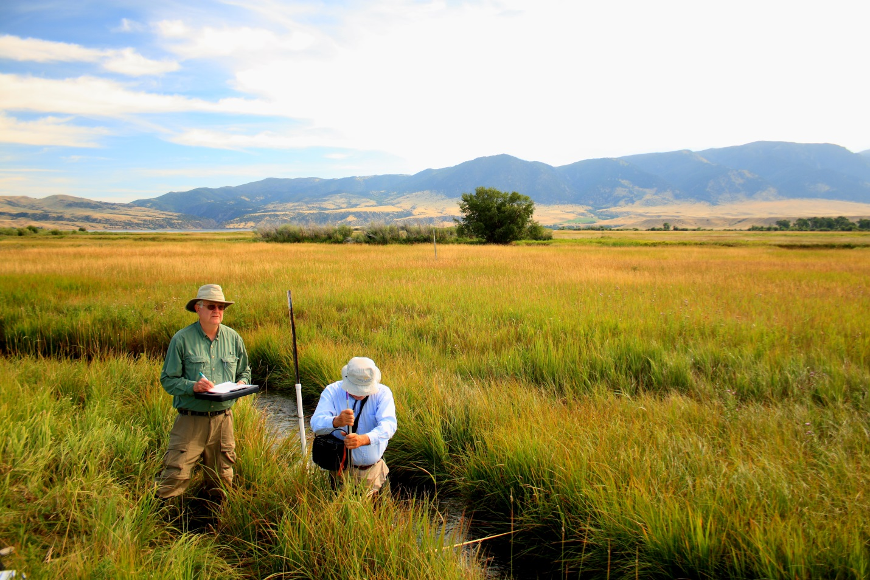**Prepared By:**

Adam Sigler & Erin Wall

MSU Extension Water Quality

P. O. Box 173120  
Bozeman, MT 59717-3120

**With assistance from:**

Ethan Kunard

Water Programs Manager

Madison Conservation District

PO Box 606

Ennis, MT 59729

Contents

Introduction 3

Project Goals and Objectives 3

Sampling Design 3

Project Team Responsibilities 5

Sampling Methods 5

Field methods 5

Flow (Discharge) Measurement 5

Water Sample Collection and Handling for Laboratory Analysis 6

Quality Assurance and Quality Control Requirements 7

Data Quality Objectives 7

Data Quality Indicators 7

Quality Assurance for Field Quality Control Samples 8

Qualifying Data that fails data quality criteria 8

Training 8

Data Analysis, Record Keeping & Reporting Requirements 9

# Introduction

This document constitutes the Sampling and Analysis Plan (SAP) for the completion of sediment and/or turbidity water quality sampling on Moore’s Creek in the Upper Madison TMDL planning area in Madison County Montana (Figure 1). This effort was initiated by the Madison Watershed Partnership (MWP) and watershed coordinator Sunni Heikes-Knapton and Water Program Manager Ethan Kunard to increase education and outreach opportunities specific to sediment and turbidity water quality issues in the Madison Watershed. An important goal of the MWP is to engage the local community through the Madison Stream Team (MST) in a way that keeps the volunteers engaged and keeps the work relevant for water resource management. Additionally, the supporting organizations recognize the value of collecting baseline water quality and quantity data on impaired waterways, specifically if the data is recognized as credible and useful for the pre-TMDL planning process.

# Project Goals and Objectives

The goals of the project are:

1. To increase community engagement in water resources and data collection to enhance understanding of local water resources.
   1. Objective: To initiate turbidity data collection as a cheap and simple method for learning about sediment concentrations in Madison watershed streams. The initial sampling design will focus on sediment load estimates surrounding Ennis, but once the methods are established the monitoring program is flexible for expansion to allow volunteers to assess other sediment related questions of interest.
2. To increase volunteer capacity to participate in the upcoming TMDL process.
   1. Objective: To Pilot collection of turbidity data as a method that could cheaply and easily be adapted to help inform sediment sources in the watershed. In addition to informing sediment loads on Moore’s Creek above and below Ennis, this method could be adapted to synoptic sampling events at sites spread out a long a stream network to inform sediment sources.
3. To foster a communication network between data collectors and land managers.
   1. Objective: To create a website that allows for easy upload of data by stream team members for immediate display for public viewing to help facilitate conversations.

Through the collection of water quality data, the project will provide the following products or opportunities:

* A summary of the results will be published in the Madison Stream Team Annual report. Annual report will be made publically available at the Madison Conservation District website.
* This will provide opportunities to reach out to landowners that may be influencing water quality conditions at specific sites.

# Sampling Design

The pilot effort will focus on Moore’s Creek and will be focused on use of a Hach turbidity meter to assess changes in turbidity moving downstream on the creek including the section passing through Ennis. This sediment source oriented monitoring seeks to maintain conceptual alignment between MST efforts and MDEQ efforts which are transitioning to TMDL planning. This project will also pilot use of a website for data entry and display which will provide a real-time way for volunteers to log and share data. Another element of this pilot will be to encourage volunteers to think about identification of potential restoration projects to address the sediment and/or other pollutant sources they observe.

Initiating a pilot sediment source monitoring program on Moore’s Creek provides opportunity for overlap with the planned virtual watershed tour development. Selection of a creek that includes both municipal and agricultural sediment sources will provide diversity in the type of sources that volunteers can collect data about and will also allow for consideration of a diversity of restoration projects.

The following sites have been initially designated for the monitoring. One site above town, one at Dave Bricker's house in Ennis, and one near the Ennis Homestead as Moore’s Creek exits town. Sites are listed below in Table 1.

**Table 1: Monitoring sites on Moores Creek**

| **Site ID** | **Site Name** | **Latitude** | **Longitude** | **Site Description** |
| --- | --- | --- | --- | --- |
| MC-MCR | Moores Creek Road | 45.332921 | -111.747695 | Upstream of Moores Creek Road crossing |
| MC-BRK | Bricker | 45.338583 | -111.737733 | Southeast boundary of Bricker (BRK) property. |
| MC-TOWN | Town | 45.349467 | -111.730019 | Downstream of Hwy 287 where stream exits culvert |

Due to the ease and simplicity of collecting data with the HACH 2100Q Turbidity meter, data collection will focus on high frequency collection at only three sites on Moore’s Creek. Although three sites will be permanent, volunteers will be encouraged to collect turbidity at other locations of interest on Moore’s Creek and potentially sites on other streams. Synoptic sampling events at sites spread out along Moore’s Creek will be organized throughout the season. Along with high frequency turbidity sample collection, TruTrack stage recorders will be placed at the three permanent sites and instantaneous discharge will be measured with a Marsh McBirney flowmate at least three times throughout the season with the goals of measuring discharge during different stages of the hydrograph (ie: rising limb, falling limb, peak flow, base flow, etc.).

Additionally, a minimum of 6 Suspended Sediment Concentration grab samples will be collected at each site throughout the year. These samples will be paired with the discharge and turbidity data in order to build a relationship showing the sediment load in Moores Creek. A rating curve will be developed between SSC concentrations and turbidity (NTU) readings to estimate SSC concentrations from turbidity readings. Likewise, a rating curve between discharge and TruTrack stage measurements will be developed to estimate discharge through the season.

# Project Team Responsibilities

The project manager will be the Water Programs Manager. Responsibilities of the project manager include pre-season meetings, volunteer coordination, storage/maintenance of equipment, data management, data analysis, report composition, coordinating educational events. The project team responsibilities are provided in Table 2.

**Table 2: Project team members and responsibilities**

| Name/Title | Project Responsibilities | Contact information |
| --- | --- | --- |
| Ethan Kunard, Water Programs Manager | Program Manager: Data Collection, analysis, report composition, coordination of educational events, equipment maintenance | PO Box 606  Ennis, MT 59729  406.682.7289  ethan@madsioncd.org |
| Adam Sigler; MSUEWQ Water Quality Specialist | Technical assistance as needed for equipment and data. | Sigler Lab, MSU, PO Box 173120, Bozeman, MT, 59717-3120  406.994.7381; asigler@montana.edu |
| Katie Makarowski  MTDEQ | Coordination on DEQ assessment monitoring. | (406) 444 – 3507; [kmkarowski@mt.gov](mailto:kmkarowski@mt.gov) |

# Sampling Methods

Sampling will be conducted according to the standard operating procedures (SOPs) outlined at the end of this document. A Site Visit Form (see end of document) will be completed for each site visit and will include all field data collected and an inventory of samples collected for analysis at the DEQ contracted laboratory. Site locations will be corroborated using this document and/or a GPS and the method will be specified on the field visit form. New sites will be georeferenced with a GPS and/or aerial imagery mapping software such as Google Earth or ESRI GIS products. The GPS coordinate system datum will be NAD 1983 State Plane Montana, in decimal degrees to at least the fourth decimal. Photographs will be taken using a digital camera.

## Field methods

Water will be collected from the middle of the vertical water column in a well-mixed portion of the stream in a designated bottle. Volunteers will collect water samples in the field, and will then bring the samples into the Conservation District office to be analyzed with the turbidity meter within 24 hours. Discharge does not need to be measured every time turbidity samples are collected but if a staff gage is present, a reading will be recorded.Turbidity measurements will be completed using a HACH 2100Q portable turbidity meter.

## Flow (Discharge) Measurement

Stream discharge data will be collected at all water quality monitoring sites using the Marsh-McBirney Model 2000 Flo-Mate. The flo-mate is a portable flow meter that uses an electromagnetic sensor to measure velocity. As resources are available, TruTrack capacitance rods will be installed and programmed to record hourly water height (mm), water temperature (C), and air temperature (C). Upon each subsequent site visit, data will be downloaded to laptop computer equipped with Omnilog Software and saved as a Microsoft Excel file with site name, date, and time of download. Measured flow and recorded height will be used to create a stage/discharge relationship for each year data is collected. Staff at DEQ suggests stage data for periods with air temperatures below freezing will be evaluated and data may be qualified based on DEQ observations that stage data accuracy decreases within this temperatures range.

## Water Sample Collection and Handling for Laboratory Analysis

Grab samples will be collected for delivery to the DEQ contracted lab for chemistry analysis using acid washed, polyethylene bottles provided by the testing laboratory. Table 6 details the analytical methods and handling procedures for each parameter.

Bottles shall be rinsed three times with stream water prior to sampling. Samples will be collected in a well-mixed portion of each stream. During sampling, the sample bottle opening should face upstream and should be drawn through the water column once, carefully avoiding disturbance of bottom sediments. Samples will be preserved in the field and stored on ice until shipment to the lab.

Table 3: Lab parameter analytical methods, reporting limits, hold times, and preservatives.

|  |  |  |  |  |  |  |
| --- | --- | --- | --- | --- | --- | --- |
| **Parameter** | **Preferred Method** | **Alternate Method** | **Req. Report Limit ug/L** | **Holding Time Days** | **Bottle** | **Preservative** |
| Suspended Sediment Concentration (SSC) | EPA 160.2 | A2540 D | 4000 | 7 | 1000 ml HDPE | ≤6oC |

Quality control (QC) samples consisting of blanks and duplicates will be collected at all sites during the first sample visit for each stream. The location and visit for QC sampling is indicated in the parameter tables in the SOPs. A field blank is prepared by transporting laboratory-grade deionized (DI) water to the field (provided by the laboratory) and pouring it into sample containers provided by the lab. The blank will be prepared at the same time that the samples are collected from the stream. A duplicate sample is a second stream sample collected at the same time in the same way that the regular stream sample is collected. In 2015, duplicate and blank samples will be collected at all sites of each stream for one event. Duplicate and blank samples are labeled according to the labeling protocol below which does not identify which sample is which to the lab. Blank and duplicate samples are handled and delivered to the lab in the same manner that regular samples are handled.

Sample labels should be filled out with Company (Madison Conservation District or MCD), the date, the time and the sample ID. The sample ID is very important and includes the year, the month, the day, the site ID and a letter indicating they type of sample (regular, blank or duplicate).

Sample ID = YearMonthDay-SiteID-Parameter ID-Sample Type Letter

* Parameter ID

TSS = Total Suspended Sediment (1L White lid)

# Quality Assurance and Quality Control Requirements

In order for water quality data to be useful, it needs to be an accurate representation of conditions in the water body at the time the samples were collected. This requires proper sample handling and processing and then assessment of data to ensure quality. Data quality objectives (DQOs) state the required quality of data for the intended use and data quality indicators (DQIs) are the specific criteria that data are assessed by to determine quality. Definitions and a list of DQIs are included in the glossary. These indicators are assessed by collecting quality control (QC) samples and then performing quality assurance (QA) checks on those samples.

QC samples are blank, duplicate and spike samples collected or created in the lab and/or the field for evaluation of quality indicators. Once the lab results are returned for the QC samples, QA is the process of assessing the data through use of indicators to determine data quality.

## Data Quality Objectives

Sites selected for this effort are based largely on accessibility for successful piloting of this monitoring approach. The sites are selected to be spatially representative of data above and below the town of Ennis.. Efforts will be made to collect samples from May through October with emphasis on high flow and precipitation related weather events, but will depend on availability and schedule of the volunteers.

Provisions are in place to ensure sensitivity of data collected to differences in stream water quality and comparability of data collected to other datasets. These provisions include the collection of grab samples and field QC for submission for analysis on the turbidity meter and for submission to a certified laboratory and assessment of QC data relative to data quality indicators. Data that does not meet quality criteria will be qualified appropriately in the annual report and during the MT EQUIS submission process.

In order to ensure the highest degree of data completeness possible, the team leaders will fill out datasheets and review them before leaving a site. The program manager will review datasheets for completeness and will follow-up with volunteers if fields are not completed. A minimum of 60% completeness (2 out of 3 scheduled events) is the goal for the project for 2015 accounting for possible weather, access, and volunteer availability challenges.

## Data Quality Indicators

Quality assurance and quality control (QAQC) can be broken down into a field and a laboratory component. The field component consists of collection of blank and duplicate samples and comparison of data to criteria. The laboratory component consists of assessment of data for blanks as well as a variety of duplicate and spiked samples analyzed by the lab. Blank samples should ideally yield results indicating “no detection” of the analyte in question. Duplicate samples should ideally produce identical results and analysis of spiked samples should recover exactly the amount of analyte added. Methods are not perfect however, so the criteria outlined in the following two sections are used to assess if data is of acceptable quality.

## Quality Assurance for Field Quality Control Samples

Prior to all turbidity measurements being taken, the calibration of the turbidity meter will be verified. Samples will not be analyzed until the meter has passed the calibration tests. Additionally, samples will be analyzed three times each, and readings must fall within 10%.

#### Quality Assurance for Lab Quality Control Samples

Certified laboratories run QC samples for at least 10% of their sample volume. Integrity of laboratory data will be determined by comparing results for laboratory QC samples to the data quality indicator criteria in Table 4. Reports with lab QC results and data quality indicator calculations should be provided by the lab with each set of sample results. Each of the quality indicator criteria in Table 4 must be checked for each analyte for each batch of samples submitted to the lab. This process is easier if a matrix is used to systematically check the numbers.

Table 4: Data quality indicator criteria for lab QC samples

| **Parameter** | **Method** | **Method Blanks** | **Lab Duplicates (RPD)** | **Lab Control LCS/LFB**  **(percent recovery)** | **Matrix Spike/ Matrix Spike Dup (percent recovery)** |
| --- | --- | --- | --- | --- | --- |
| Suspended Sediment Concentration | ? | ? | ? | **?** | **?** |

## Qualifying Data that fails data quality criteria

If any of the data quality objectives for field or laboratory QC samples fail the criteria above, all data for that analyte for that sample batch must be qualified accordingly. Note that a blank which exceeds the threshold does not automatically mean all data for that sample batch must be qualified. Sample results with values greater than 10 times the detected value in the blank do not need to be qualified. A narrative in the annual sampling report should outline what data was qualified and for what reason. The data will also need to be qualified during the process of uploading to MT EQUIS using the appropriate qualifier codes.

# Training

Select volunteers will begin monitoring in Spring 2015, and will receive training on a one-on-one basis. Volunteers will be trained on methods for collecting turbidity with the HACH 2100Q portable turbidity meter. Additionally, they will be trained on methods for collecting SSC samples for lab analysis, and discharge using the Marsh-McBirney Flometer. Volunteers will also be shown how to properly fill out site visit forms. All other Madison Stream Team volunteers who did not receive the one-on-one training will be trained on these same methods during a full day training planned for June 2015.

# 

# Data Analysis, Record Keeping & Reporting Requirements

Data will be recorded on field forms once samples have been analyzed. That data will then be entered into an excel spreadsheet that will contain all turbidity data for analysis.

Copies of laboratory analytical reports and electronic data deliverable spreadsheets will be provided by the DEQ contract analytical lab to both the project manager, and to DEQ. The project manager will review the laboratory data to ensure lab results are within reporting limits (including the laboratory QA/QC samples) prior to data entry into MT EQUIS. A review of field and analytical data will be conducted following receipt of the laboratory data package that includes all items on the QC Checklist.. Data qualifiers will be assigned to data in both hardcopy and electronic form that does not meet these target quality control criteria. A brief synopsis of any SAP methodology derivations that occurred will also be drafted.

Data generated during this project will be stored on field forms and in laboratory reports obtained from the laboratories. Site Visit and Chain of Custody forms will be properly completed for all samples. Written field notes, field forms, and digital photos will be processed by field staff following QA/QC procedures to screen for data entry errors. Data from all sampling events will be entered into EQUIS. Records of miles driven per volunteer monitor or monitoring crew will be kept to reimburse volunteers. Records of number of hours worked by volunteer monitoring crews will also be tracked for purposes of budget tracking.



Table 1: Sample field form for MC-MCR site