Photo Monitoring Guidance
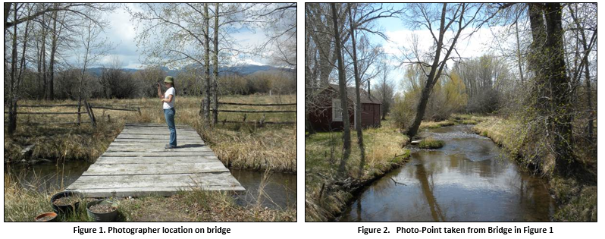

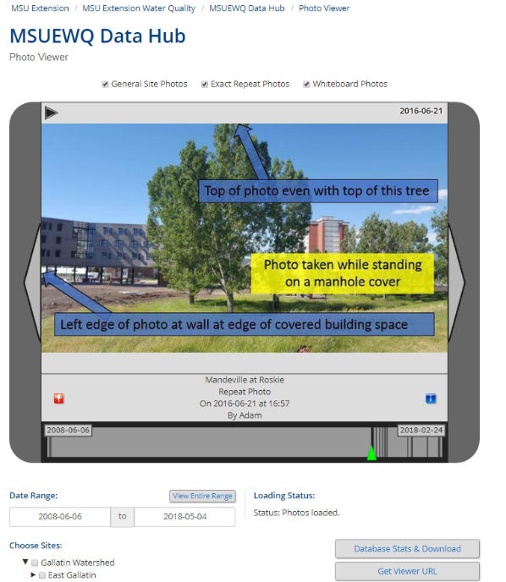

Written by:
Adam Sigler, MSU Extension Water Quality (MSUEWQ) and
Robby Robertson, Big Sky Watershed Corp and MSUEWQ

Updated May 25th, 2018 by Adam Sigler

Contents
1. Introduction to Photo Monitoring 3
2. Types of Photographs 3
3. Defining Monitoring Objectives 4
4. Establishing Photo-Point Sites 5
4.1. Identifying the location where the photographer will stand 5
4.2. Defining what is framed in the image 5
5. Standard Operating Procedures (SOPs) 7
5.1. Adapting these SOPs for your needs 7
5.2. Considerations When Taking Photographs 7
5.3. Equipment Needed 7
5.4. Field Procedures 8
5.5. Photograph Metadata 9
5.6. Example Photo-Point Datasheet 9
5.7. Photo management and storage 10
6. Uploading Photos to the MSUEWQ DataHub 11
6.1. How to Access the Photo Database 11
6.2. Requesting Site Permission 12
6.3. Choose Existing Photopoint 13
6.4. Request a New Photopoint 13
6.5. How to Upload a Photo into the Database 14
6.6. How to Upload Photo from a Mobile Device 16
7. Photo Administration in MSUEWQ DataHub 20
7.1. How to Download and Backup Photos 20
7.2. Correcting issues with Uploaded Photos 22
7.3. Recognizing Partners in the MSUEWQ DataHub 25

Introduction to Photo Monitoring
Landscape photographs can offer a qualitative and, in some situations, quantitative evaluation of the current and trending conditions in a watershed or on a waterbody. The details contained within photographs provide insight into a number of ecological parameters and environmental conditions that can be logistically challenging to measure, thus making photo monitoring cost effective. The parameters and conditions that can be documented with photographs range from stream bank erosion and riparian vegetation regeneration to assessing restoration effectiveness or consequences of natural disasters. If repeated for a sufficient period of time, these photos can be used to evaluate resource conditions over time and help inform management decisions. Modern camera technology is inexpensive, widely available, and simple to operate. In addition to being valuable pieces of scientific data, photographs can also be used in reports and presentations as a powerful tool to explain what is going on in the field. This document outlines photo monitoring and photo storage in the MSUEWQ DataHub.

Types of Photographs

- Photo-points
Photo-points are photographs that are taken at a specific location to address a specific objective. These photographs will always be taken from the same position and oriented in the same direction with the same vertical angle. The goal is to recreate the same scene within the picture so changes can be documented. Using the same camera through time is not required but will make it easier to exactly repeat the photo. Camera operators must take extra precaution when taking photo-points to ensure they are in the correct location and are pointing the camera in exactly the correct direction, as well as recording the necessary information about the photograph (metadata).

- Supplementary Photos
Supplementary photos can be taken of features or evidence of activity within the stream and riparian area that are either unusual or of interest. These photos do not need to be taken in any particular position, but should be documented with the same information (metadata) used with the photo-points. In the extreme case of an extraordinary finding, such as Bigfoot, GPS coordinates should be recorded in the photo description section of the datasheet. Examples of supplementary photos include:

  - Evidence of flood damage
  - Invasive plants
  - Unidentifiable plants or animals
  - Extreme erosion
  - Irrigation structure damage
  - Turbidity events
  - Trash dumps
  - Happy volunteers

Defining Monitoring Objectives
Photo-point sites should be selected to answer the questions you are interested in. It is important to identify the specific stream attributes of interest, so photo-points capture changes in those attributes. To do this, the monitoring objectives of the program must be carefully considered and clearly defined. The following tables (adapted from the NRCS Quick Guide to Photo Point Monitoring) provide guidance for photo monitoring to meet different objectives. This guidance applies to both repeat and supplementary photos.

Riparian and Instream Habitat Improvement Projects
Restoration Action | What/When to Photograph
Livestock fencing | Pre-project photos should capture representative stream bank profiles prior to fencing. Post-project photos should show fencing, and changes in vegetation and stream bank erosion.
Riparian planting | Pre-project photos should capture future planting location before site preparation. After planting, take photos showing changes in vegetation structure.
Non-native plant management | Pre-project, photos of weed patches or distribution in the area to be treated; post-project, similar photos of the area and/or of non-weedy vegetation establishing
Bank stabilization | Take pre- and post-project photos from the opposite bank and from mid-channel, looking across stream to future treatment location.
Boulder/LWD placement | Take pre- and post-project photos from mid-channel looking upstream and downstream from each structure location. Take more photos from either bank looking down on structure.
Weirs/grade control | Take pre- and post-project photos from mid-channel looking upstream and downstream from each structure location. Take more photos from either bank looking down on structure.

Wetland Habitat Improvement Projects
Restoration Action | What/When to Photograph
Non-native plant management | Pre-project, photos of weed patches or distribution in the area to be treated; post-project, similar photos of the area and/or of non-weedy vegetation establishing
Planting | Pre-project photos should capture the future planting location before site preparation. After planting, take photos that show changes in the vegetation structure.
Reestablishment of wetland hydrology | Photograph area where hydrology will be restored. Make sure to take post-project photos during the appropriate season so changes will be visible.
Upland Habitat Improvement Projects
Restoration Action | What/When to Photograph
Juniper management | Pre-project photos should capture areas where juniper treatment will occur. Include ground so that vegetation reestablishment and reduction of sediment loss can be captured in post-project photos.
Non-native plant management | Pre-project, photograph area to be treated. Make sure to capture enough in the pre-project photos so that you will be able to detect changes in the post- project photos.
Grazing management | Photograph area prior to change in use and implementation of grazing management, and photograph again in following years.

Water Management Projects
Restoration Action | What/When to Photograph
Irrigation system improvement | Pre-project, photograph old structures and intended location of new structures. Post-project, take photos showing restoration and demonstrating that structures are still operational.
In-stream flow protection | Photograph stream reach before project implementation. Take monitoring photos at weirs or other specific points

Establishing Photo-Point Sites
General locations for photo points should be identified based on monitoring objectives as outlined above. For repeat photos, it is then necessary to establish exact locations and camera angles where photos will be taken. This requires easily identifiable features for where the camera should be positioned and where the camera should be pointed. These features should be permanent and not affected by changes in foliage or other seasonal changes. The person or team establishing the photo-points should be familiar with monitoring objectives and the project area, but subsequent repetition of photos should be straight forward for anyone to do with the right documentation. An easily repeatable photo will be more useful than a detailed photo than cannot be recreated.

Identifying the location where the photographer will stand
An aerial image, a map, and/or GPS can get photographers close to the point where they should stand to take images, but a definitive feature or marker on the ground is also necessary. Examples of features include: a steel fence post driven into the ground, a large distinct tree, a bridge, a staff gauge, an irrigation structure, or a building. A photograph of a person standing in the location where the photographer should stand (Figure 1) can be very helpful. Avoid using the zoom feature because it will make the photo more difficult to repeat. Descriptions of where the camera should be placed and what defines the frame should be included in a Site Guide for future photographers and should include an example photo along with photos indicating where to stand.

Defining what is framed in the image
Once the camera location is identified, the camera angle and tilt should be adjusted to capture the stream attributes of interest while simultaneously having easily identifiable features are at the edges of the frame. There should be at least one feature helping identify the tilt of the camera (vertical alignment) and at least one feature helping identify the direction the camera is facing (horizontal). The top or bottom of the frame might be defined by the top or bottom of a telephone pole, or a distinctive branch on a tree. Similarly, the horizontal angle might be defined a stump, the edge of a building, a bridge piling, etc.
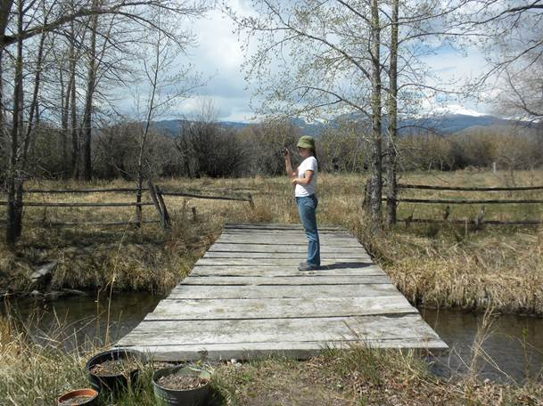Figure 1. Photographer location on bridge
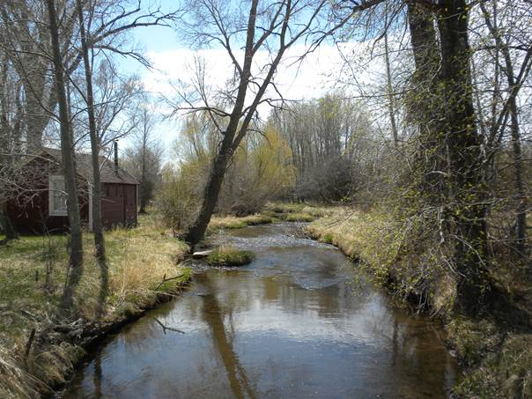Figure 2. Photo-Point taken from Bridge in Figure 1

Example of Poorly Repeated Photos:

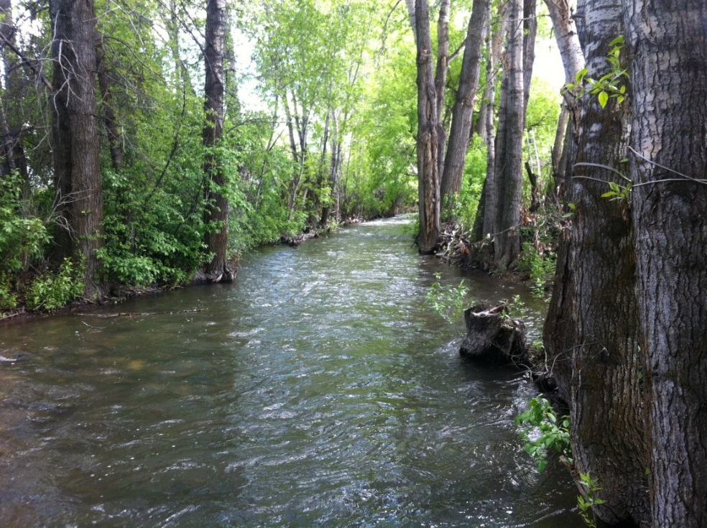
Bottom of photo defined by bottom of this large tree.
Right edge of photo defined by right edge of this large tree.
Original Photo-Point

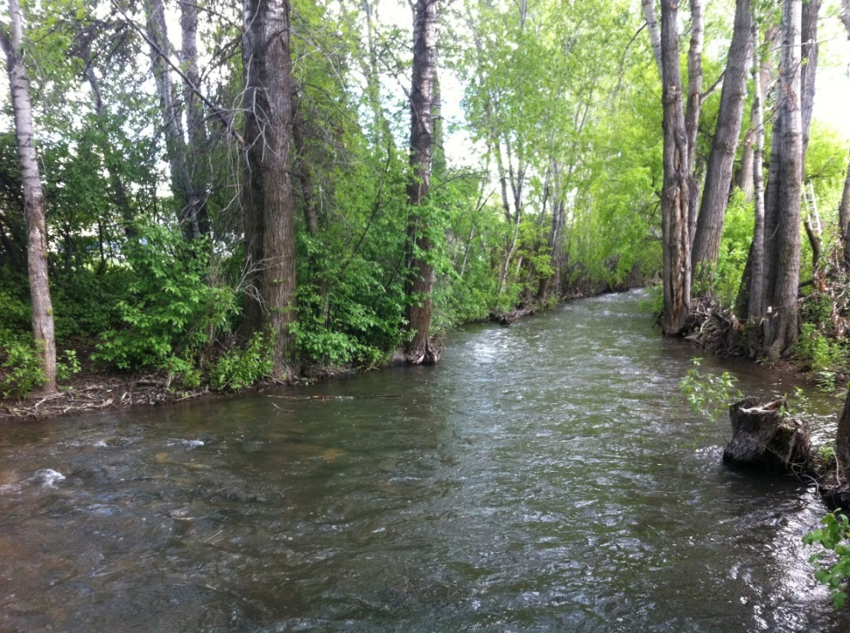
The large tree is completely missing from the photo.
The photo is close to a repeat because this stump is in a similar location.
Poorly repeated Photo-Point

A few definitive features in the original photo are included in the repeat, so the repeat photographer was close but did not repeat the photo precisely. It appears that the photographer pointed the camera too far to the left, missing the distinctive tree on the right and capturing an additional tree on the left side of the image.
When these photos are viewed sequentially in a time lapse video, the image will jump around and not provide a uniform view of change at the site over time.

Standard Operating Procedures (SOPs)

Adapting these SOPs for your needs
These SOPs should be modified to match the needs of your individual monitoring effort. The use of whiteboards for instance is a very useful way to know which photos were taken at which site at what time even if datasheets are lost and/or if camera times are set incorrectly. If volunteers are going to be monitoring with cell phone cameras and/or uploading photos immediately to an online storage database, the whiteboard approach may not be necessary.

Considerations When Taking Photographs
It is critical that photo-point photographs are an exact replicate of previous photos. This will require the use of the Site Guide for each location that includes directions to the site and instructions for locating and repeating photos. The first thing you need to do is locate the position that the photograph is to be taken from. The second task is to identify the features in the photo that let you know you are repeating it exactly. In addition to photo-point photographs, supplementary photographs can be taken at the photographer’s discretion to document interesting conditions at the site. Artistic expression is encouraged as some photos may be used on websites and in slide shows. Season and weather conditions should be considered when scheduling monitoring events especially if there are implications for site accessibility. Scheduling events to capture different stream flow levels and seasonal changes in vegetation can be advantageous. The camera should not be zoomed in unless specifically directed in the Site Guide.

Equipment Needed
Required:
- Camera and backup camera
- Site Guide
- SOP
- White board
- Dry erase marker
- Rag to erase white board
- Topographic and/or road map
- Compass (if cardinal directions are included in photo guide)
- Timepiece
- Extra batteries for camera (if applicable)
- Photo-log data sheets
- GPS unit

Optional:
- Aerial photos if available
- Staff gauge or yardstick (for scale on landscape shots)
- Ruler (for scale on close up views of streams and vegetation)
- Steel fence posts for dedicating fixed photo points in the absence of available fixed landmarks (only necessary for initial site establishment)

Field Procedures
Once at a monitoring site, the following steps should be performed:

- First, take a photograph of a white board that displays the information about the site. The whiteboard should be photographed before any site photos are taken and again after all photos are taken at the site to facilitate data management. Information on the white board should include stream name, site ID, date, photographer name, and start time (example below).

West Fork of the Madison
WF-CNF
July 6, 2011
D. Stout
Start 10:30 AM

- Ensure that the date and time in the camera are set correctly. If they are not correct and you cannot figure out how to reset them; make a note of the incorrect time on the datasheet.
- Confirm photographer location with either existing marker (steel fence post), GPS, or by referencing the description contained within the Site Guide.
- Locate the definitive feature for the given photo-point and correctly align the feature within the camera’s view using a compass
- Take a photograph. Be sure not to zoom in.
- With digital cameras, confirm photograph is as close to a complete duplication as possible to the original photograph.
  - Pay particular attention to the corners of the old photo. Does your photo have the same features in each corner?
  - Does your photo look like it is too close or too far away? If so, move accordingly.
  - Is the horizon the same?
- Record the appropriate information (metadata) on the datasheet.
- Once all photos have been taken, update the whiteboard with the end time and the number of photos taken and photograph the board (example below). A photo of the whiteboard should be the first and last photograph taken at each site.

West Fork of the Madison
WF-CNF
July 6, 2011
D. Stout
End: 11:35 AM
5 photos taken

Photograph Metadata
Depending on monitoring objectives and photo storage plan, consider what information should be stored about your photos. Examples include:
- Photo file name (.jpeg)
- Date and time when photograph was taken
- Name of photographer
- Location (site and stream)
- Description of photograph
- Site or project conditions at the time of photo
    - General stream flow conditions (flooding?, drought?)
    - Project implementation status

Example Photo-Point Datasheet
JPEG # | Date | Time | Photographer | Site ID | Photo Description | Definitive Feature Description
123 | 6/14/11 | 13:00 | D. Stout | WF-CNF | Looking upstream atop bridge | Barn smoke stack azimuth = 125°

Photo management and storage
Thoughtful and timely management of photos is important to ensure they are not lost and that photo location and information is logged accurately. A management and storage plan should be included in a project sampling and analysis plan (SAP). All photos should be stored in at least two locations. The MSUEWQ DataHub is an option for uploading photos to the internet for easy public viewing.

Thoughtful consideration of the file/folder structure for storing photos on the computer is critical. Years and site locations are the most basic types of considerations. Renaming a lot of photos with site names and dates can take a lot of time, so saving photos into folders named by site is one approach. If the whiteboard approach is used, sequential images will be bracketed by a picture with the site name and time. This can allow for photos from multiple sites and/or multiple visits to be stored in the same folder without renaming photos, as long as file names are sequential, which is common for digital cameras (assuming a single camera is used).

Uploading Photos to the MSUEWQ DataHub

How to Access the Photo Database
- Contact Adam Sigler to get a username and password to the MSUEWQ DataHub.
- Visit http://waterquality.montana.edu/datahub to access the photo database.
- Log in using your provided credentials. The first time you log in, you will be prompted to change your password.
- If photo-points already exist for your project, follow the photo upload steps below.
- If photo-points need to be established for your project, correspond with Adam Sigler to get those points created.

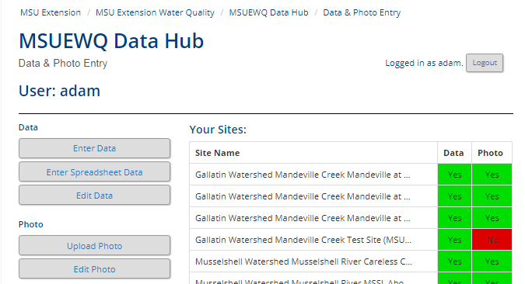
Uploading photos
- Once logged into the database you should see a screen similar to the following. Select “Upload Photo”

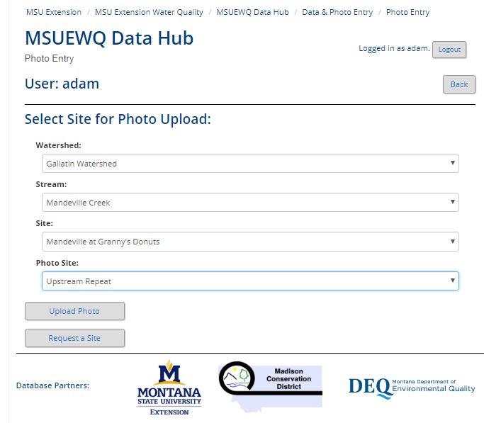

- Use the drop down boxes to select the photo point you have a photo for and click “Upload Photo.”

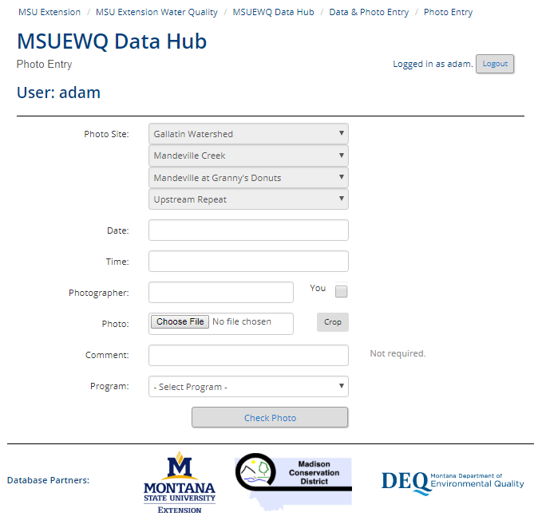
- Fill out each of the fields with the information for your photo. Click “Choose File” and select the file from your computer hard drive.
- Click “Check Photo” to ensure the photo and information are correct and then click the final button to upload.

How to Upload Photo from a Mobile Device
This process is very similar to that outlined above. This section of the SOP can be fleshed out as necessary.

Photo Administration in MSUEWQ DataHub

How to Download and Backup Photos
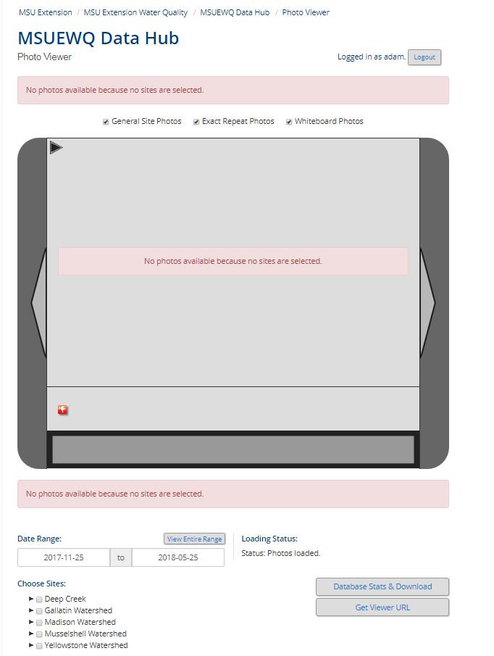
- Navigate to the photo viewer within the MSUEWQ DataHub
http://waterquality.montana.edu/datahub then select “Photo Viewer”
- Click, “Database Stats & Download” button.

- Once in the stats page click, “Download Photos”.

- At this point you can choose which photos you would like to download, you can make your selection based on watershed, stream or site as well as within a date range.
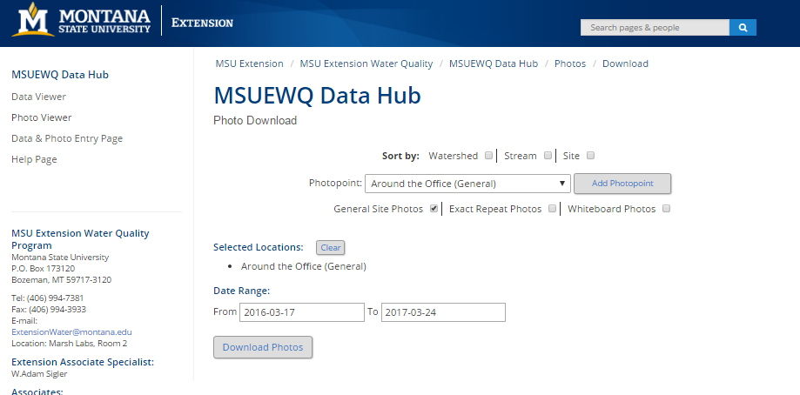
- Once you click, “Download Photos” a box should pop up asking you whether you want to save or open the zipped file with the photos. Save the file to your preferred location and unzip the photos to view them.
- Photos will be organized in folders by photo-point. Individual photos will be named with the date and time of the image.

Recognizing Partners in the MSUEWQ DataHub

Logos of partners to stream monitoring organizations can be uploaded to the data hub and displayed when photos from that program are viewed. To add parnter logosyou’re your program, email Adam Sigler with each of the logos you would like uploaded and he can add those to your program information so they display when your organizations photos are viewed. See the example below for the Madison Stream Team.
