2014 Ruby Watershed Volunteer Monitoring Program
Discharge, Turbidity, and Photo Point
Sampling and Analysis Plan
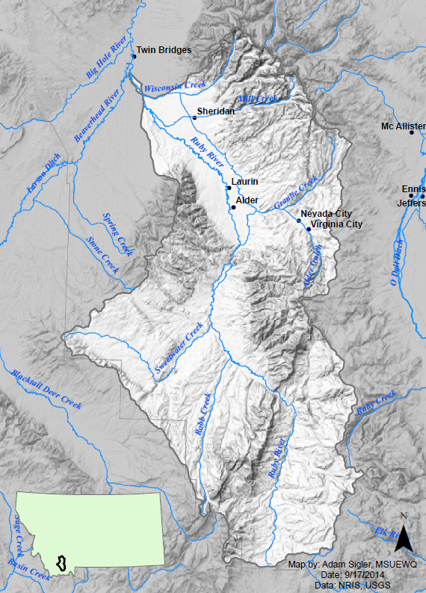

Prepared by:
Katie Kaylor and Adam Sigler (MSU Extension Water Quality)
in cooperation with
Rebecca Ramsey and Dave McAdoo (Ruby Watershed Council)
Table of Contents
Introduction 1
Project Area Overview 1
Project Goals and Objectives 2
The goals for starting a volunteer monitoring include: 2
Objectives of preliminary data collection initiated in the fall of 2014: 3
Study Design 3
Site Selection 3
Sampling Methods 5
Turbidity – Hach Meter 5
Flow (Discharge) Measurement - meter method 5
Photo Points 5
Other Methods 5
Data Management 6
Quality Assurance 6
Quality Control 6
Data Quality Objectives 6
APPENDIX A: Standard Operating Procedures 6
Gear Checklist 6
Field Activity Checklist 6
Sampling Sites And Parameters 6
Site Photos 6
Example Field Visit Sheet 6
Turbidity Measurement With Secchi Tube 6
Turbidity Measurement With Hach 2100q Turbidimeter 6
Calibrating The Hach 2100q Turbidimeter 6
Discharge Using The Float Method 6
Discharge Using The Marsh-Mcbirney Flo-Mate Meter 6

Introduction
This document constitutes the Sampling and Analysis Plan (SAP) for data collection by the newly established Ruby Watershed Volunteer Monitoring Program. This effort was initiated by the Ruby Valley Conservation District (RVCD) and the Ruby Watershed Council (RWC) with technical assistance from MSU Extension Water Quality (MSUEWQ).

Project Area Overview
The Ruby River watershed, located in southwest Montana, is bordered by the Tobacco Root Mountains to the east, the Ruby Mountains to the west, and its headwaters are south in the Snowcrest and Gravelly mountain ranges. The Ruby meets the Beaverhead and Big Hole Rivers at Twin Bridges to form the Jefferson River. Farming and ranching are primary land uses in the watershed and the area has an extensive mining history, largely in the mountain valleys which is often on or surrounded by US Forest Service land.

Figure 1. Ruby River Watershed Map

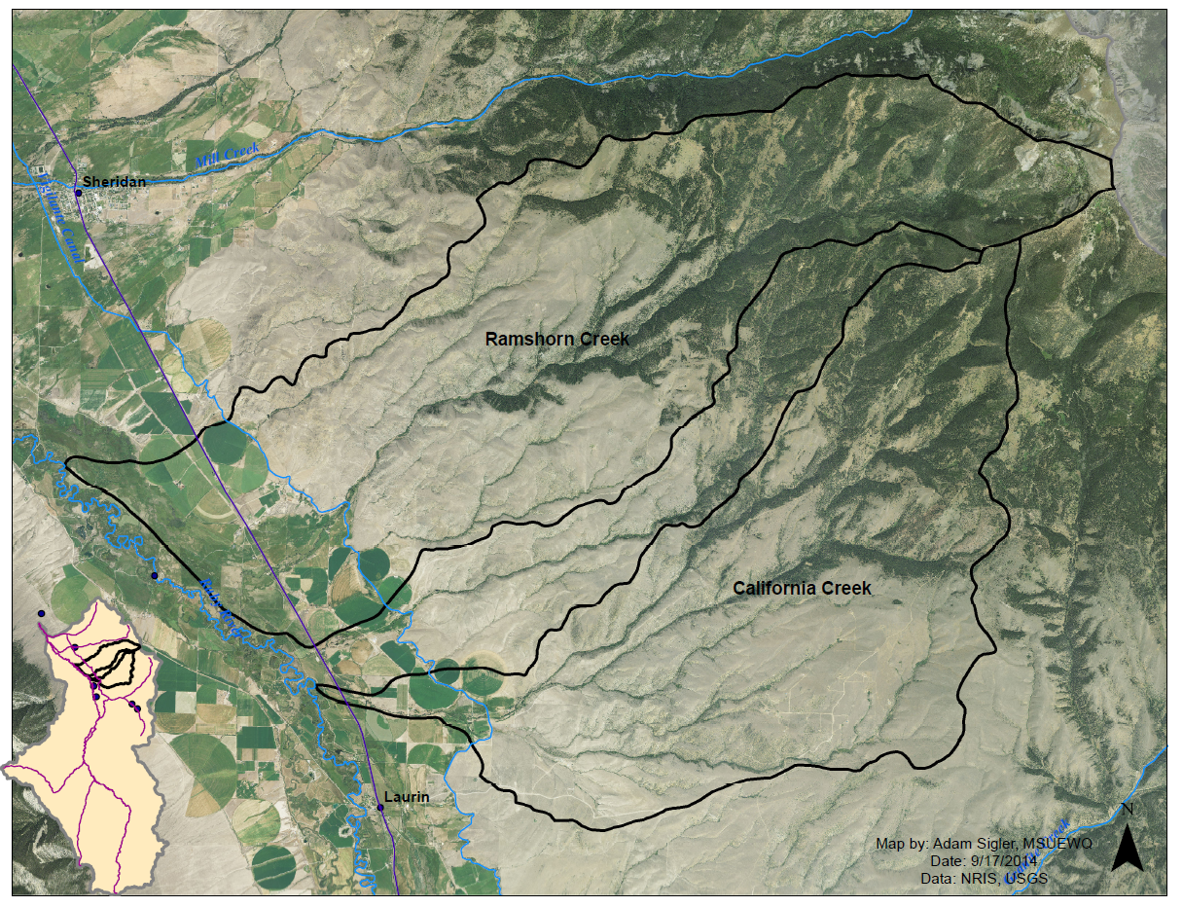
Figure 2. Ramshorn and California Creeks

Project Goals and Objectives
Articulating goals and objectives for starting a monitoring program are critical first steps to ensure program outcomes match group intentions. While goals outline the bigger picture vision for a program, objectives are more specific and include indication of how the data will be used. The following goals and objectives come from notes and summary documents compiled by MSUEWQ from conversations with members of the RWC during meetings on February 18th and May 27th 2014.

The goals for starting a volunteer monitoring include:
- To increase public engagement in water resource management
- To understand current stream conditions and potentially help identify opportunities for restoration projects
- To evaluate whether best management practices (BMPs) are effective at improving water quality or stream conditions
- To ultimately get streams taken off of the MDEQ impaired water bodies list

Objectives of preliminary data collection initiated in the fall of 2014:
- To engage interested volunteers, provide an initial training and start some data collection in order to produce some momentum with data collection.
- To collect basic flow and sediment data which could potentially be leveraged into more advanced sediment data collection efforts in subsequent seasons.
- This effort will ideally involve some collection of data on Ramshorn and California Creeks which have been identified by the RWC as focus streams for initial sediment management efforts. However, the effort will also be considered successful if sediment and/or flow data are generated on other waterbodies within the Ruby watershed to get the data collection rolling.

Table 1. Project Team Responsibilities
Person | Role | Contact Info | Training | Responsibilities
Rebecca Ramsey | CD Coordinator | rubywatershed@gmail.com | MWCC Training, RST Training | -volunteer coordination  -landowner communication  -data compilation from volunteers
Jennifer Konopacki | Monitoring Volunteer | Removed from web version |  | Data collection
Dave McAdoo | Monitoring Volunteer | Removed from web version | MSUEWQ Training 9/19/2014 | Data collection
Adam Sigler and Katie Kaylor | Technical Assistance | asigler@montana.edu  kkaylor@montana.edu |  | Conduct trainings, assist with documentation, assist with data organization and presentation

Study Design

Site Selection
Although the direction and purpose of a volunteer water monitoring project in the Ruby is still being solidified by the RWC, monitoring efforts commenced in the fall of 2014 to kick start data collection and establish initial sample sites based on volunteer availability and interest. Three sites were selected on September 19, 2014 by Dave McAdoo (volunteer) and Adam Sigler (MSUEWQ). Two sites were established at the Ruby Habitat Foundation (RHF), one on the Ruby River, near the Beat 3 Bridge and the second site is on California Creek approximately 50 feet upstream of the confluence with the Ruby River. Sites on the RHF were established due to ease of public and stream access. A third site was established on Indian Creek on the Morse Land Company property. This site is on private property, but is convenient for Dave McAdoo to monitor as he frequently visits the site to monitor a re-vegetation project. Steps for establishing new sites are also included in the standard operating procedure (SOP) appendix to facilitate volunteers establishing new sites that are of interest to them. This is to provide flexibility during this formative stage of the project.

Table 2. Sampling Locations
Site | Site Description | Latitude | Longitude | Parameters | Justification of Site Selection
R_RHF_B3B | Ruby River at Ruby Habitation Foundation Beat 3 Bridge | 45.373465° | -112.142101° | Turbidity | On publicly accessible land with easy access and on the main stem of the Ruby which could be interesting to a broader group that individual tributaries
C_RHF_CNF | California Creek at Ruby Habitat Foundation upstream of confluence with Ruby River | 45.373158° | -112.134245° | Turbidity | On publicly accessible land with easy access on a stream identified as being of interest to the RWC and just before the confluence with the Ruby River
I_MLC_URP | Indian Creek at Morse Land Co. Upper Revegetation Plot | 45.461242, | -112.269991 | Turbidity, Discharge | Site that Dave McAdoo will be near on a regular basis for easy data collection and where the landowner may be interested in the data as well.

Sampling Methods

Each site has a turbidity data sheet where data will be recorded every time a sample is collected. On Indian Butte creek, a staff gage is present and stage will be recorded each time a turbidity sample is collected. When time allows, discharge will be measured at the Indian Butte Creek site as well and discharge data sheets will be completed.

Turbidity – Hach Meter
Turbidity grab samples will be measured with a Hach 2100Q turbidimeter. Volunteers have the option to bring the meter streamside and immediately analyze the water or to collect a sample in a small plastic vial and analyze the water back at the location where the turbidimeter is being stored. The SOP outlines step-by-step instructions on how to properly collect and analyze samples using the turbidimeter.

Flow (Discharge) Measurement - meter method
Stream discharge data will be collected at the Indian Creek site when time allows. MSUEWQ loaned a Marsh McBirney velocity meter and top setting rod to the RWC at the time of the September 19th training for temporary use. The SOP outlines step-by-step procedures for operating this meter and provides example datasheets.

Photo Points
Photographs will be collected at each site when a sample is collected by using a personal phone camera or digital camera. Shots of upstream, downstream and cross section photos are recommended to capture stream conditions at the time of the sampling. Photos will be kept by volunteers until the end of the season and then transmitted to Rebecca Ramsey and to MSUEWQ.

Other Methods
Measurement of turbidity can also be accomplished with a secchi tube and MSUEWQ has purchased one for the RWC. This method was not covered in the training on September 19th but is very conducive for data collection by students as well as adults. Similarly, discharge can be measured with the float method which does not require expensive equipment and is conducive for collection by students or adults. Both of these methods are covered in the SOPs for reference.

Data Management

Turbidity and discharge datasheets will be delivered to Rebecca Ramsey at the Ruby Valley Conservation District office at the end of the sampling season. The datasheets will be scanned and saved on the XXX computer under XXX filepath and named Year_SiteName_TurbidityData. The data will also be manually entered into an excel worksheet. Discharge data sheets will be handled in a similar manner. Photos will be emailed to Rebecca Ramsey and saved on the computer at the file path referenced above. All scanned datasheets and Excel files of entered data will be transferred to MSUEWQ and compiled into basic plots with assistance from MSUEWQ for presentation to the watershed group.

Quality Assurance

Quality Control
Quality assurance will be addressed through collection of duplicate samples for quality control. Samples will also be analyzed three times on the turbidity meter. This will allow for calculation of precision among measurements and samples collected at the same time to account for possible sample error.

Data Quality Objectives
Initial data quality objectives are not quantitative and are simply to have data be of sufficient quality that volunteers are confident to present the results to other members of the watershed group.

APPENDIX A: Standard Operating Procedures

Gear Checklist

Field Activity Checklist

Sampling Sites And Parameters

Site Photos

Example Field Visit Sheet

Turbidity Measurement With Secchi Tube

Turbidity Measurement With Hach 2100q Turbidimeter

Calibrating The Hach 2100q Turbidimeter

Discharge Using The Float Method

Discharge Using The Marsh-Mcbirney Flo-Mate Meter

